Demore, McFadden

Lab 11v

ECE 332

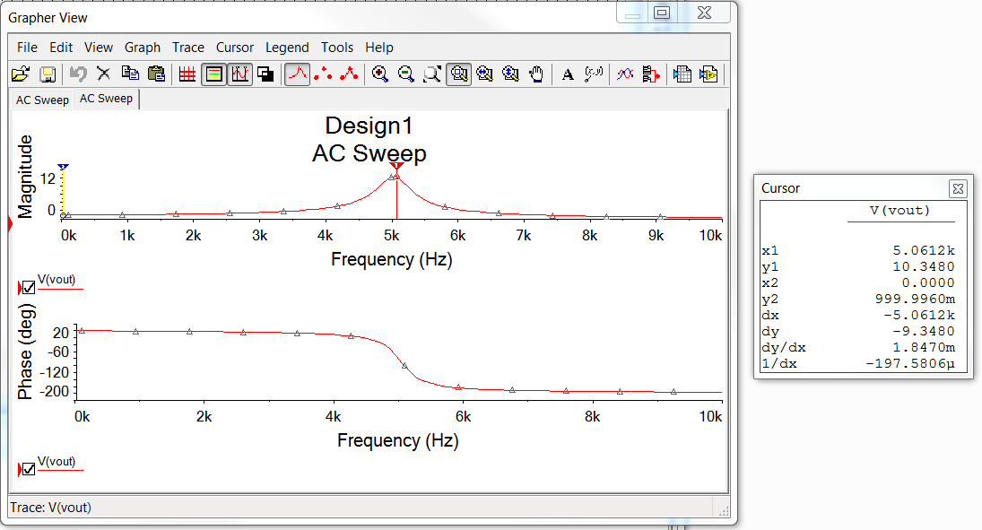

Figure 1: Lab 9s Results

Figure 2: Lab 11v Results